**UMUCSurvery Test Plan**

Files: UMUCSurvey.java

Author: John Bernat

Date: 06Nov2016

**Description:**

This program will prompt the user to enter various data and will read data into variables. Calculations for average quiz score and conversion for temperature Fahrenheit to Celsius will be processed. Then the program will output the user data to the console.

**Input:**Bold text show the input data for the prompts.

Enter your Student EMPLID (0 - 999999): **4301**

Enter your quiz1 percentage score (0.0 – 100.0): **89.1**

Enter your quiz2 percentage score (0.0 – 100.0): **82.1**

Enter your age (0-120): **32**

Enter the current Temperature in degrees Fahrenheit: **32.0**

**Expected output:**

******* Thank you for completing our survey ********************************** Student EMPLID: 4301

Quiz 1 Score: 89.1

Quiz 2 Score: 82.1

Average quiz score: 85.6%

Temperature in Celsius: 0.0°

Age: 32

**Actual output:**

******* Thank you for completing our survey **********************************

Student EMPLID: 4301

Quiz 1 Score: 89.1%

Quiz 2 Score: 88.2%

Average quiz score: 88.65%

Temperature in Celsius: 0.0°

Age: 32

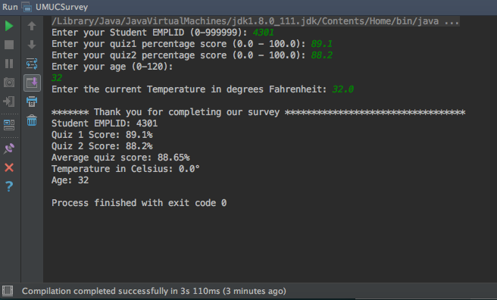

**Pass/Fail:** Pass